Meals-To-You Home Delivery Program
Nutrition and Support for Rural, Low Income, Low Access Students

The USDA is providing expanded funding for at-home food delivery to students in rural areas throughout Texas, New Mexico, Alaska, and the Navajo Nation through the Meals-To-You program this summer. This funding will allow Meals-To-You to deliver 1 week of nutritious, shelf-stable foods direct to student’s homes for up to 10 weeks, helping reduce food insecurity in your community.

Once your school or district is enrolled in the program, our immediate priority is to ensure that you have the tools you need to rapidly enroll your students.

HOW STUDENT ENROLLMENT WORKS
- Families must visit MealsToYou.org and click on the HOUSEHOLD ENROLLMENT button.
- Then, click on the “Register as a new household” link, and complete the sign-up form.
- The sign-up form must be completed for EACH child in the household who needs to receive the meal delivery.

This Partner Toolkit we developed includes materials and assets you’re welcome to use to help get the message out to your parents and families and ensure that we can get meals to as many children as possible.

We appreciate your ongoing support of the Meals-To-You program and for helping to make a difference in the lives of children and families without access to healthy meals.

Best,

Melissa Hunter

Melissa Hunter
VP of Marketing, McLane Global
mealstoyou@mclaneglobal.com

Partner Toolkit Assets

- Draft E-Newsletter Content

- Draft Social Media and Text Messaging Content

- Flyers:
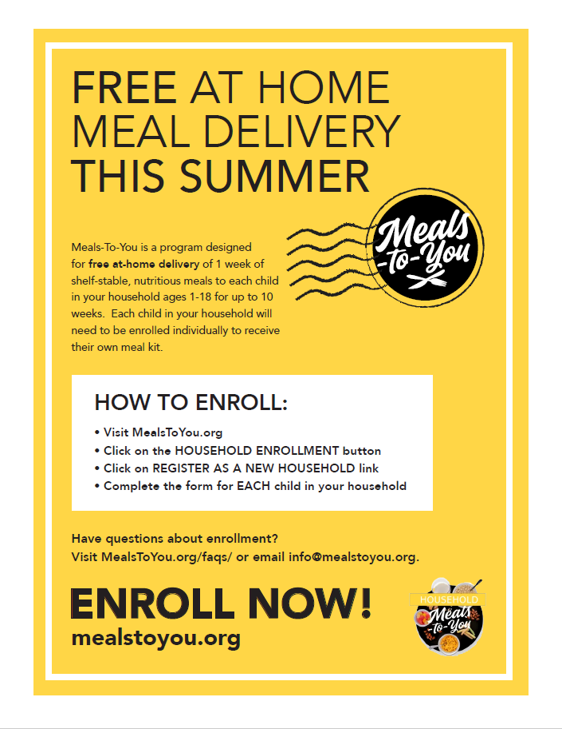Meals-To-You Yellow
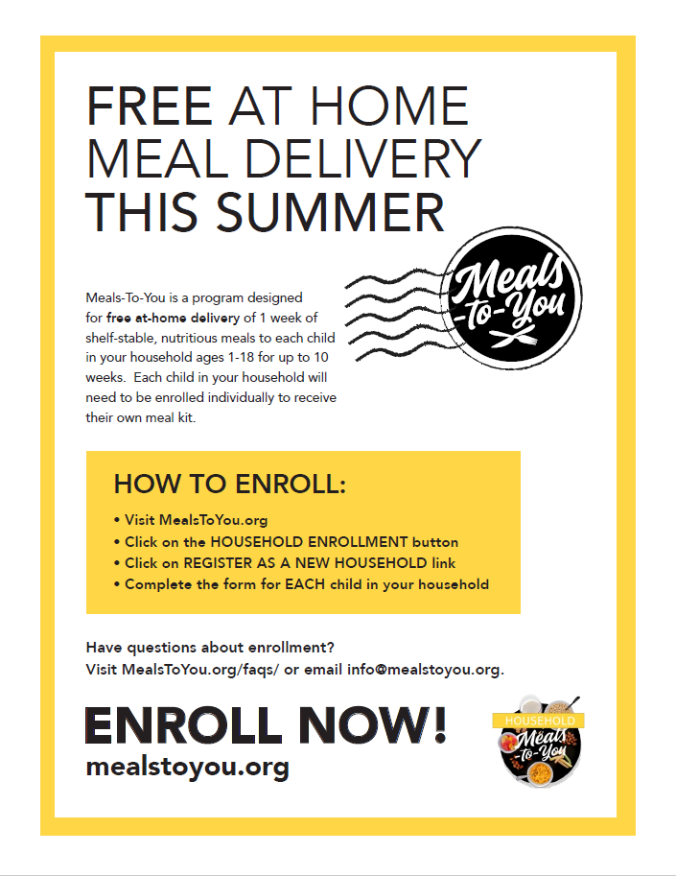Meals-To-You White

Questions about this toolkit?
Email us at: mealstoyou@mclaneglobal.com

E-Newsletter Content

Subject Line: At-Home Delivery of Free Meals for Children This Summer

Dear Parents and Students,

We are pleased to announce our school has enrolled in the Meals-To-You program this summer. This program is designed for free at-home delivery of 1 week of shelf-stable, nutritious meals to each child in your household ages 1-18 for up to 10 weeks.

Meal kits include foods such as milk, cereal bowls, snacks, entrees, fruit cups and juices for one student. Each child in your household will need to be enrolled individually to receive their own meal kit.

How To Enroll:
- Visit MealsToYou.org
- Click on the HOUSEHOLD ENROLLMENT button
- Click on REGISTER AS A NEW HOUSEHOLD link
- Complete the form for EACH child in your household

Help us make sure that your children are signed up to receive essential nutrition throughout the summer. Have questions about enrollment? Visit MealsToYou.org/faqs/ or email info@mealstoyou.org.

Thank you and have a great summer,

The Meals-To-You program is a public-private partnership with the USDA, the Baylor Collaborative on Hunger and Poverty, McLane Global and PepsiCo, designed to reduce food insecurity in rural America through at-home delivery of nutritious foods.

Social Media Content

Social media images:

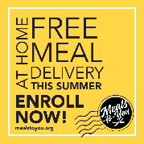 Image 1
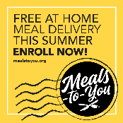 Image 2
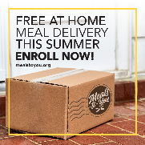 Image 3
Facebook
We’ve enrolled! Now we need your help!
[SCHOOL NAME] students can receive FREE nutritious, shelf-stable foods delivered to their home for up to 10 weeks this summer. TO SIGN UP: visit http://www.mealstoyou.org and click the HOUSEHOLD ENROLLMENT button. You must sign up each child age 1-18 in your household, individually, to receive their own meal kit.
Questions? Visit http://www.mealstoyou.org/contact

Twitter
Get FREE food delivered to your home this summer for up to 10 weeks with Meals-To-You! TO SIGN UP: visit http://www.mealstoyou.org and click the HOUSEHOLD ENROLLMENT button. You must sign up each child age 1-18 in your household to receive their own meal kit.

Text Message
[SCHOOL/DISTRICT NAME] has enrolled in the Meals-To-You program this summer. You can receive FREE nutritious, shelf-stable foods delivered to your home for each child age 1-18 in your household for up to 10 weeks. Sign up at http://www.mealstoyou.org and click the “Household Enrollment” button.

###

